**EBS vs Instance Store:**

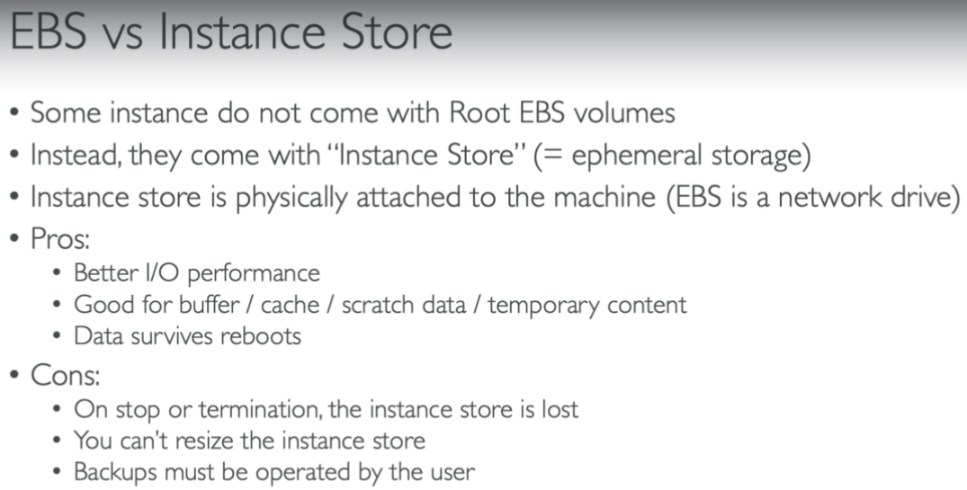

* Instance store IOPS is very fast because it is physical and EBS IOPS is till some particular limit only.

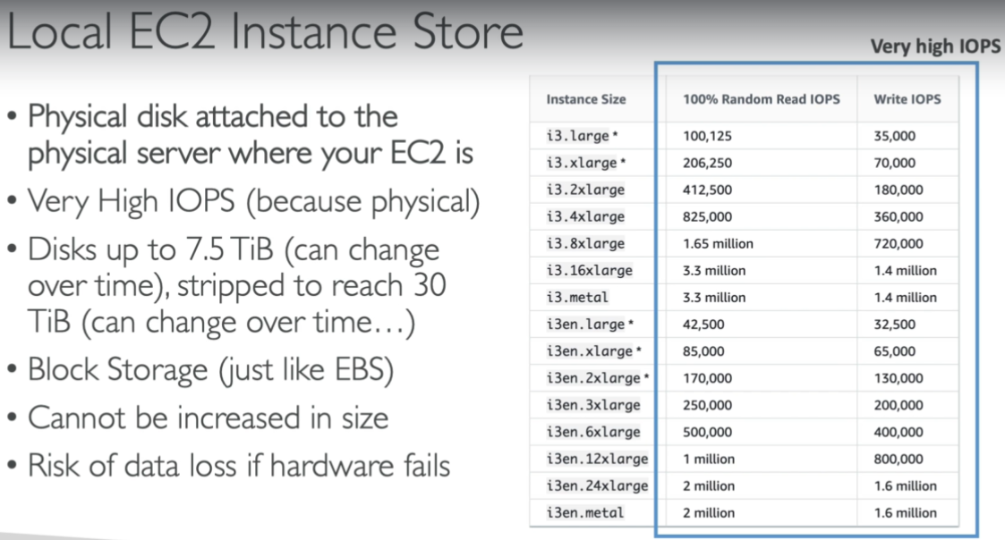

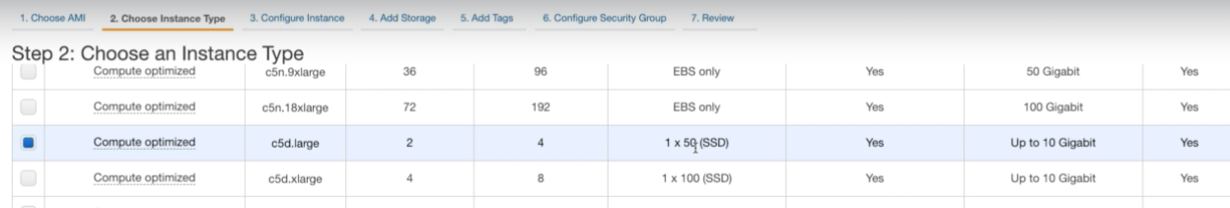

* We can that c5d.large has instance storage. While creating the ec2.

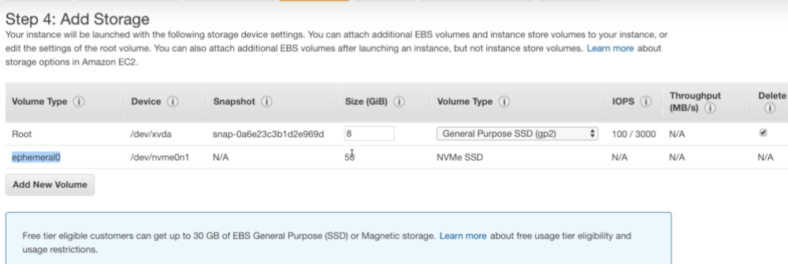

* In the next step, we can see that ephemeral storage of 50GB is attached to the server which will be faster. This way we can select the instances which comes with ephemeral and create it.